Mini project excel and power bi
1. Data Pre-processing using Excel
○ Perform cleaning and transformation tasks on raw data such as:
■ Removing duplicates
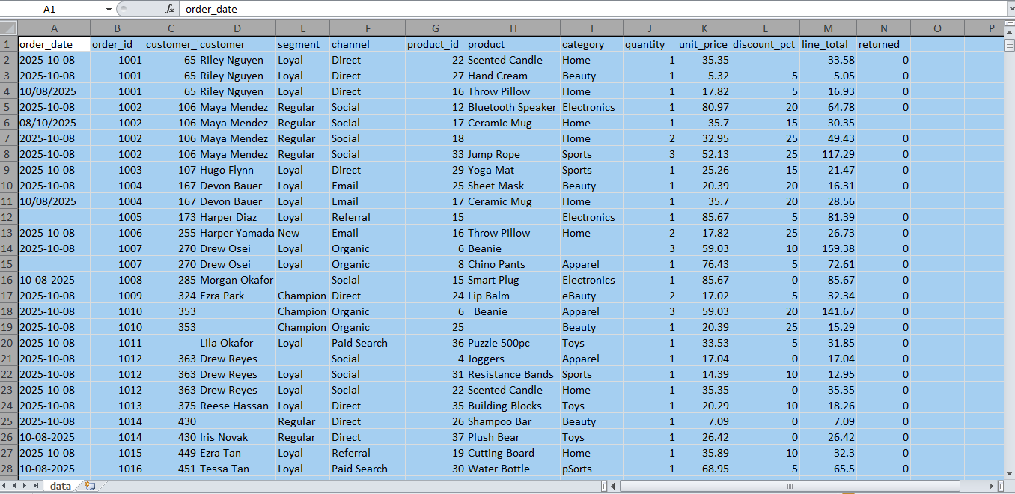
■ Handling missing values
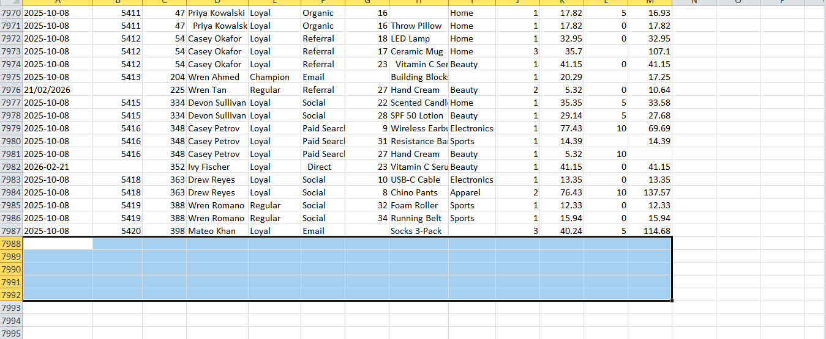
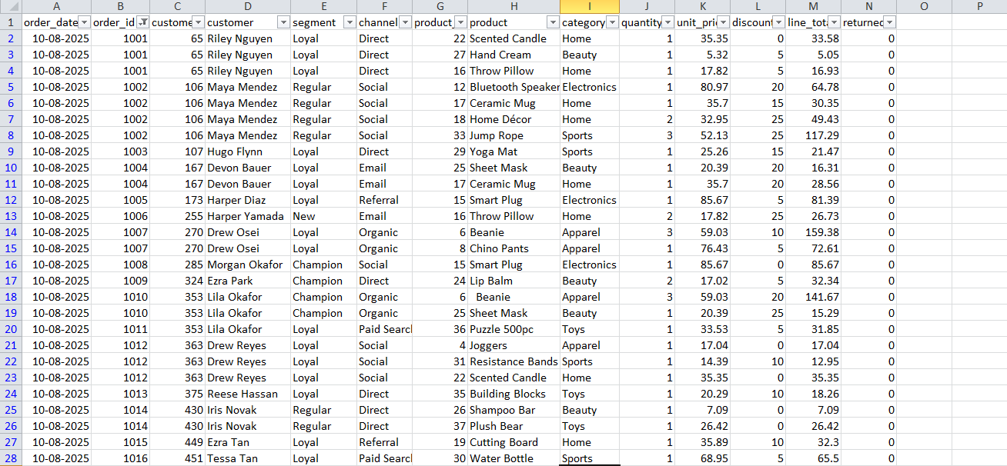
■ Standardizing formats
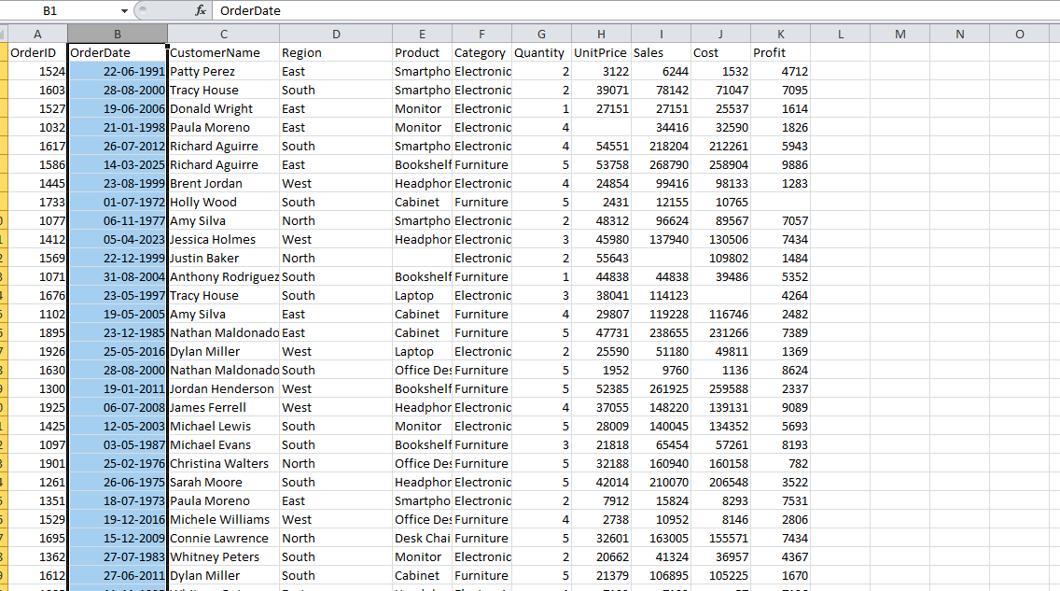

■ Creating calculated fields (if required)
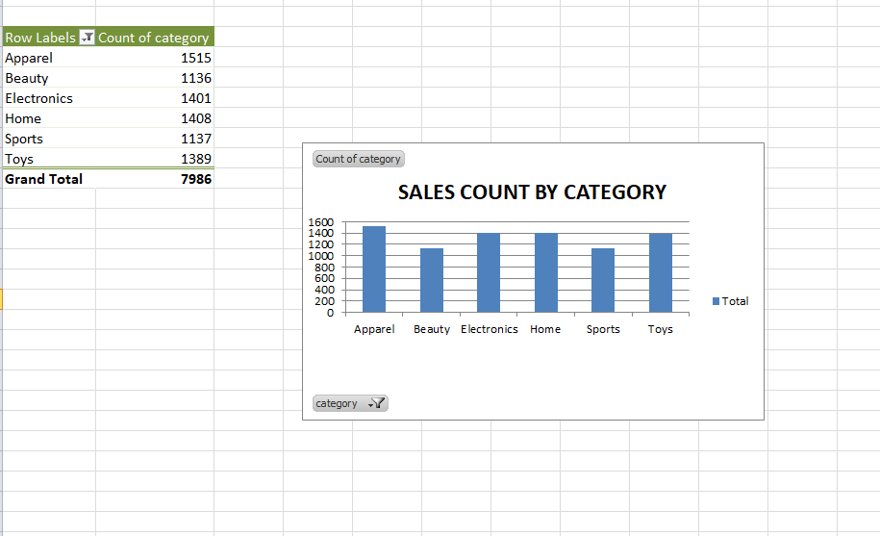
■ Filtering and sorting
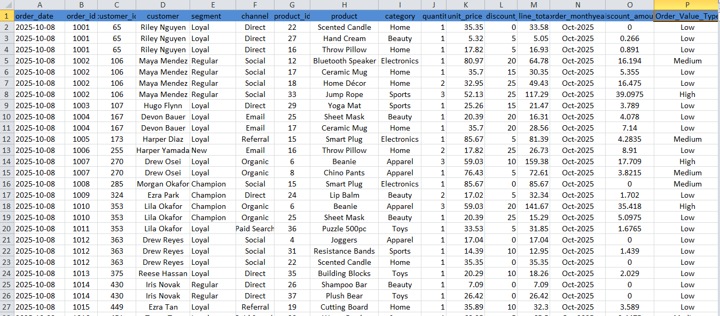
■ Creating Pivot Tables (if required)
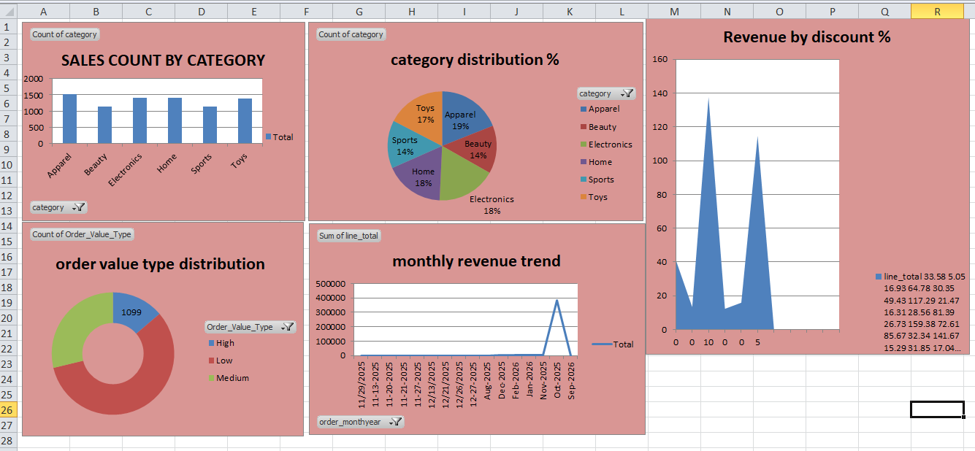

2. Data Visualization using Power BI
○ Build a report/dashboard with:
■ Multiple visualizations that communicate insights clearl
■ Appropriate use of charts (bar, line, pie, slicers, cards, etc.)
■ Clear and interactive layout (using filters, slicers, drill-downs, etc.)
■ Proper titles, labels, and legends
